Periodontal Maintenance or a “Regular Cleaning” – What’s the Difference??
By Dr. Richard Kim
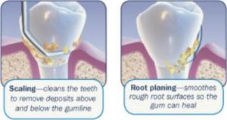
Well over half of Americans have some form of gum disease; if you are one of them then your dental cleaning not a “just” a cleaning. Patients often ask the hygienist, “what’s the difference between periodontal maintenance and a regular cleaning?” a fair question since the cost is different and it may feel like very similar procedure!
A “regular cleaning” is typically recommended every six months for patients who have healthy gums and bone… think of it like changing the oil in your car periodically to protect and prevent damage to a healthy engine. During this appointment, we remove stains, soft plaque and hard calculus (tartar) above the gums, and check for cavities.
Periodontal disease is a bacterial infection caused by plaque that destroys the bone and fibers holding the teeth in place. Just like catching a cold, some people are more at risk than others. Smoking, stress, certain medications, diabetes and prior gum problems are just some of the things that can increase your risk. When we treat the disease, our goal is to stop the infection by cleaning and disinfecting the roots of the teeth above and below the gums in a procedure known as scaling and root planing. Ordinarily, this procedure takes place in two visits, during which the hygienist may use a local anesthetic and will usually treat one half of your mouth at a time.

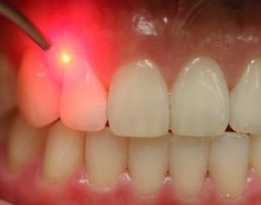
Periodontal disease is not cured… very much like Diabetes, it is a chronic condition that can be controlled. Unfortunately, once bone damage has occurred, it is generally permanent and the resulting defects (pockets) are impossible to keep clean just using ordinary tools like floss, brush and Waterpik. Modern techniques such as laser therapy and the placement of antibiotics under the gum line in the periodontal pockets have helped many avoid gum surgery and tooth loss. However, good disease control is a team effort which depends upon your careful oral hygiene at home and frequent office visits to monitor and maintain your gums and bone.
The frequency of these office visits will vary according to individual needs – however, studies show that after scaling and root planing it only takes three months for the bacteria accumulate in these pockets to the point where they caused the problem in the first place. Most people are able to stay healthy when they schedule maintenance visits at 3 to 4 month intervals. At each periodontal maintenance visit, we’ll clean and disinfect above and below the gums, measure the bone level and take periodic x-rays. We might detect one or more areas of the mouth that have begun to relapse, in which case we can treat the area before it becomes a bigger problem. On the other hand, if there has been no change, that means the schedule is working for you; your periodontal disease is controlled and we should stay the course!
Good periodontal health has many proven benefits that extend beyond clean teeth… it can affect blood sugar regulation in Diabetics as well as your heart, respiratory and reproductive health -even your family’s health – just to name a few. Don’t underestimate your maintenance appointment … it is so much more than “just a cleaning”.

